|  |
| --- |
| MSC SOFTWARE DEVELOPMMENT |
| Advanced Object Technology |
| Assignment 2 |
|  |
| **Jimmy Collins – R00145569 – Jimmy.Collins@mycit.ie** |
| **5/2/2017** |

|  |
| --- |
|  |

Contents

Section 1 – Introduction 2

Section 2 – Demonstrated Usage of Defined Object Technologies 7

Template Pattern 7

Proxy Pattern - Remote Proxy 8

Usage of Database for Data Persistence 9

Façade Pattern 11

Command Pattern 12

MVC Compound Pattern 13

Section 3 – System UML Diagram 14

Section 4 – Screen Captures of Most Impressive Code Snippets 15

Example of Integration with DShield API 15

Using Apache POI Library to Generate Excel Output 16

TODO – Snippet from new drill-down UI? 17

Section 5 – Evaluation of Work 18

Appendix 1 – Database Setup Instructions 19

Appendix 2 – Possible Development Environment Certificate Issue 20

Appendix 3 – Code Commit Analysis 22

Contributions 22

Code Frequency 22

## Section 1 – Introduction

Before setting out developing the requirements for Assignment 2, I had some improvements I wanted to make on the Assignment 1 codebase:

* User interface changes to split out general / advanced / settings sections of the user interface, I completed this by using the Accordion control to separate out the options for each section and by consolidating the tabs in the user interface from Assignment 1.

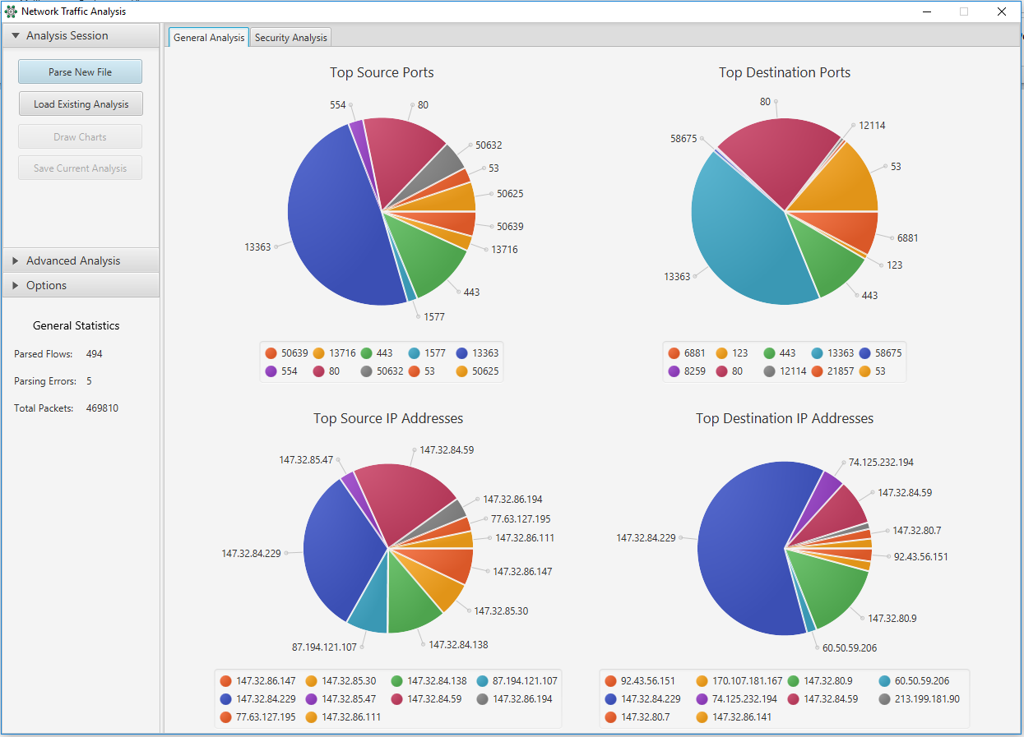

*Figure 1: Main User Interface for Assignment 2*

* Secondly, there were some changes I wanted to make to my strategy pattern implementation from Assignment 1. In the initial code base, each Strategy object was returning a Tab control meaning it was tightly couples to that UI element. I modified it so it just returns a Chart.
* Finally, I completed some general code refactoring (removed some duplicate code and other small items I missed in Assignment 1.

Regarding the Assignment 2 requirements, Section 2 contains details on how each requirement is implemented within the application.

For the data drill down requirements, I decided to take offer two pieces of functionality:

* A **security analysis** of the top source/destination port numbers and IP addresses. I do this by integrating with the DShield API[1] maintained by the Internet Storm Center (ISC). This analysis shows some indicators in the user interface that could allow the user to determine if the IP/port was recently used in an attack or for example if a certain IP has been the source of destination of a lot of malicious traffic. I also display the current threat level from the ISC in the user interface. A graphic of the Security Analysis user interface can be seen in Figure 2.
* A deeper dive on the port activity? TODO

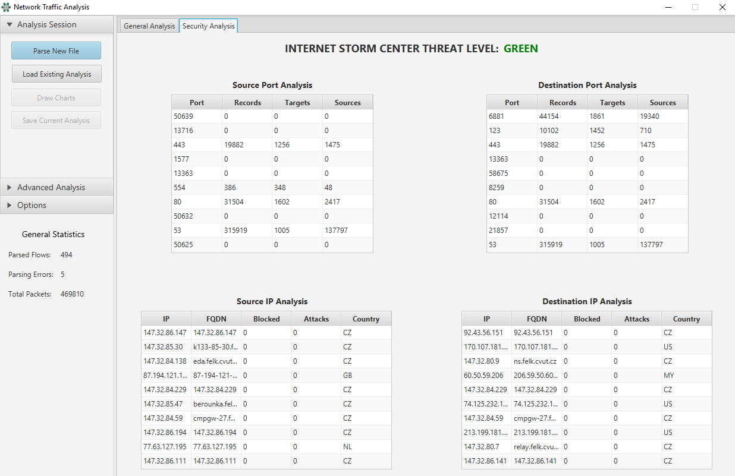

*Figure 2: Security Analysis UI*

TODO – UI for deeper dive tab (ports?)

## Section 2 – Demonstrated Usage of Defined Object Technologies

### Template Pattern

I used the template pattern to refactor some code from Assignment 1, which is the logic that is used to generate the top source/destination ports and top source/destination IP address data from the data parsed. Now the TopData class exists, which is an abstract class with the final method GetTopData, and the helper methods Initialize and GetData which are overridden in each of the concrete classes.

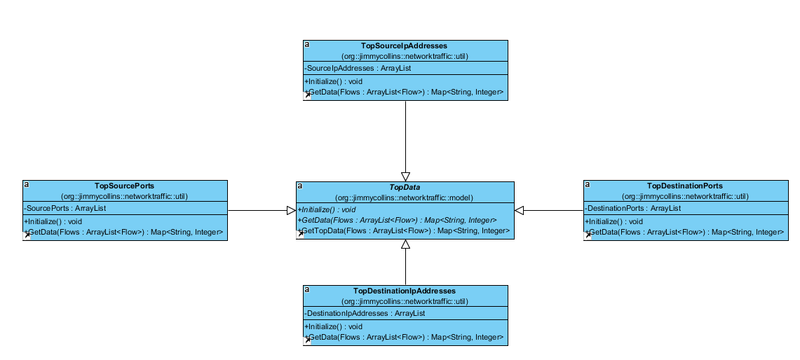

### Proxy Pattern - Remote Proxy

The usage of a remote proxy is demonstrated in UML below. In my application I integrate with the DShield[2] API maintained by the Internet Storm Center (ISC). I decided to approach some of the advanced analysis requirements from a security perspective, so I use this API to return some security information on the top IP addresses and ports that are being parsed from the Netflow file. Please see **Appendix 2** for the solution to a possible certificate issue that may occur the first time you run the application and attempt to connect to the API.

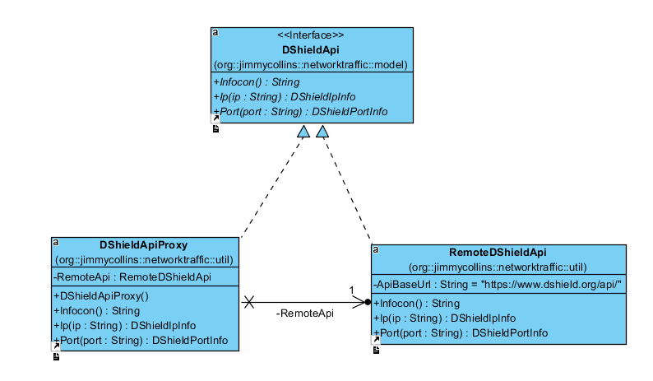

### Usage of Database for Data Persistence

Within the application the user has the ability to save an analysis session to the database. This saves the Top Source/Destination Port and Top Source/Destination IP data to a MySQL database (see **Appendix 1** for the setup details). I consciously chose not to save the data in the ‘Security Analysis’ section, as this data is something that a user would want to check each time an analysis is run, as potential threats are constantly evolving.

The database schema is shown *on the next page*.

Below is shown the class I use to handle the connection to the database, which implements the Singleton Design Pattern.

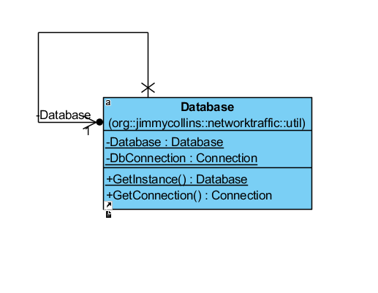

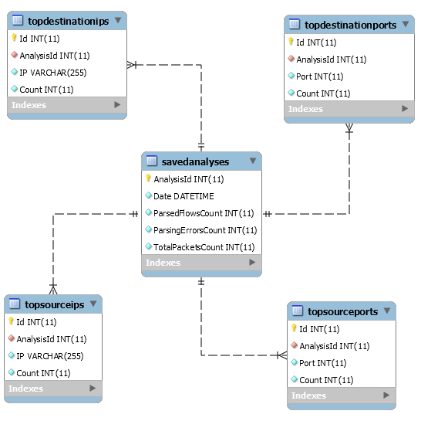

### Façade Pattern

I used the Façade Pattern to refactor my database querying functionality after it had been written, the code was quite complex before this.

I ended up creating a new class, DatabaseUtil, which is a wrapper that contains a set of members that are used for database operations that are easily understood and simple to use.

These members access the database on behalf of the facade user, hiding the implementation details.

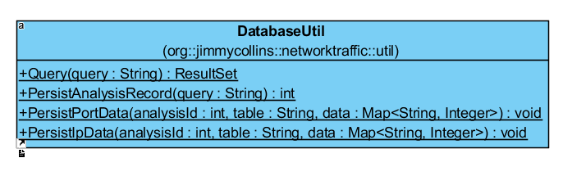

### Command Pattern

I used the command pattern for the functionality that allows a user to export an analysis to different formats (e.g. to email to someone). Currently Microsoft Excel and HTML formats are supported as export formats. I used the Apache POI[3] API to create the Excel document.

ExportCommand is the interface which both concrete commands ExportExcelCommand and ExportHtmlCommand implement. DataExporter is the receiver and the main UI controller class is the invoker. The DataExport class is just a class used to pass the relevant data to be exported to the constructors of the concrete commands.

**Notes** – adding a new export type could be facilitated easily in this design. I’m also aware that a Strategy Pattern could have been used here to achieve the same functionality.

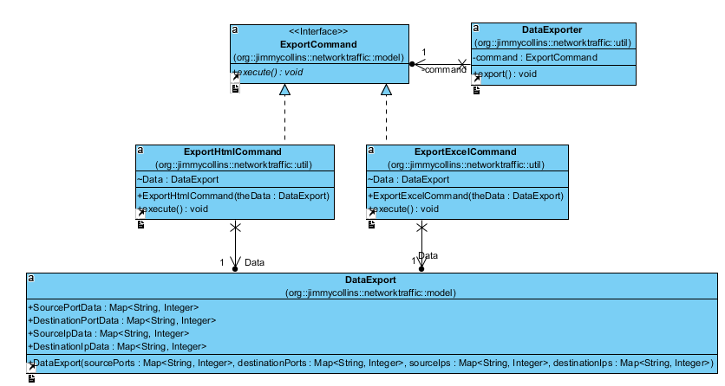

### MVC Compound Pattern

I am using the Model-View-Controller pattern within my application.

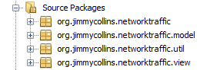

* The application user is interacting with my main user interface (i.e. the View) contained in the org.jimmycollins.networktraffic.view package.
* The action taken by a user is relayed to the Controller for the View.
* The Controller makes requests to Models and associated helper classes to perform the action, and a resulting action is relayed back to the view.

Within the MVC Pattern, I am also using other patterns such as the Strategy Patter in order to allow the user to perform actions on the user interface (changing the chart types at runtime in the case of the Strategy Pattern).

TODO – UML Example of MVC?

## Section 3 – System UML Diagram

TODO

## Section 4 – Screen Captures of Most Impressive Code Snippets

### Example of Integration with DShield API[4]

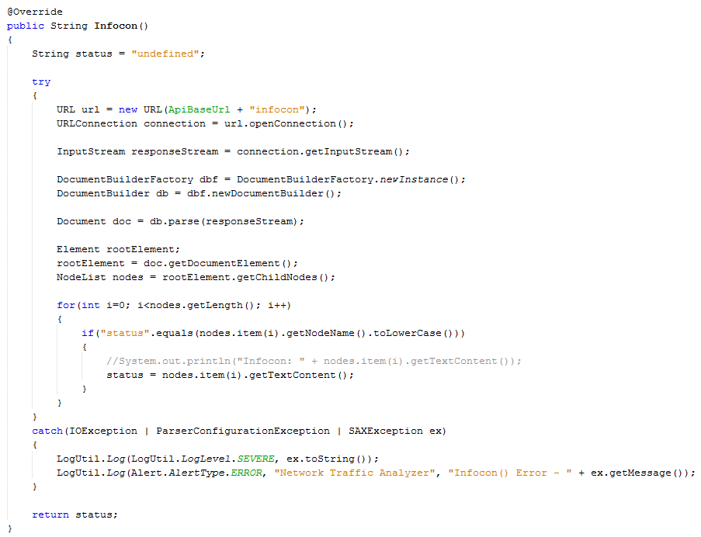

### Using Apache POI[5] Library to Generate Excel Output

(*Example truncated due to length*)

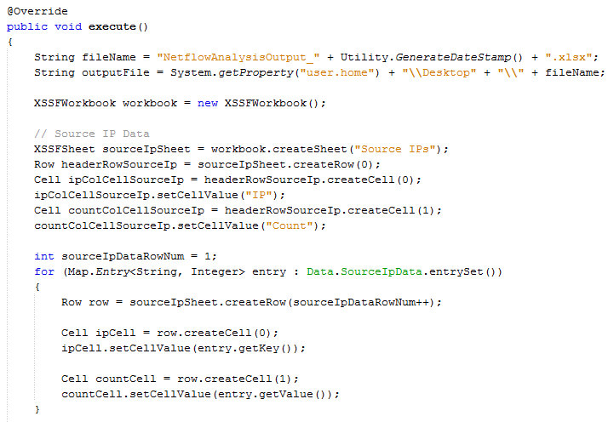

### TODO – Snippet from new drill-down UI?

## Section 5 – Evaluation of Work

TODO

## Appendix 1 – Database Setup Instructions

The below steps should be taken to create the necessary schema in MySQL for the application. This is used to save the analysis data.

1. Open MySQL Workbench and create a new connection.
2. Open 'schema-no-data.sql' from the 'db' folder in the source tree.
3. Execute this SQL to setup the necessary tables and relationships.

Note I have used MySQL Workbench to create the schema etc. but this could be run from the command line via (ensure to create the networktraffic database first):

mysql -u username -p networktraffic < schema-no-data.sql

## Appendix 2 – Possible Development Environment Certificate Issue

The following issue may occur when you try to run the ‘Security Analysis’ feature under the ‘Advanced Analysis’ menu.

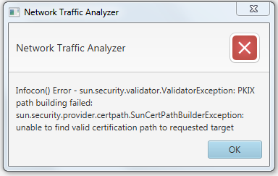

This appears to be because the server has a self-signed certificate.

To work around this issue and get the application running on your local environment, you can add this certificate to the list of trusted certificates of your JVM.

If you see this issue on your environment, please follow the below steps to fix it.

* Go to [www.dshield.org](http://www.dshield.org) and export the certificate. This can be accomplished (using Chrome) as follows:
  + Navigate to [www.dshield.org](http://www.dshield.org) at least once.
  + Next go to chrome://settings/, show advanced settings and click on ‘Manage Certificates…’.
  + In the dialog find the below certificate, and use the export option to export it locally on your machine as a .CER file.



* Next, you need to add this to the list of trusted certificates of your JVM. Go to your JRE_HOME/bin or JDK/JRE/bin
* Run the below command (substituting the path to your JDK directory and the path to the certification downloaded above):



* If promoted for a password, use the default key-store password ‘changeit’.
* When prompted to trusted the certificate, type ‘yes’.

The application should now work as expected. I’ve successfully tested this procedure on two machines.

## Appendix 3 – Code Commit Analysis

### Contributions

### Code Frequency

1. <https://www.dshield.org/>
2. <https://www.dshield.org>
3. <https://poi.apache.org/>
4. <https://www.dshield.org/api/>
5. <http://poi.apache.org/>